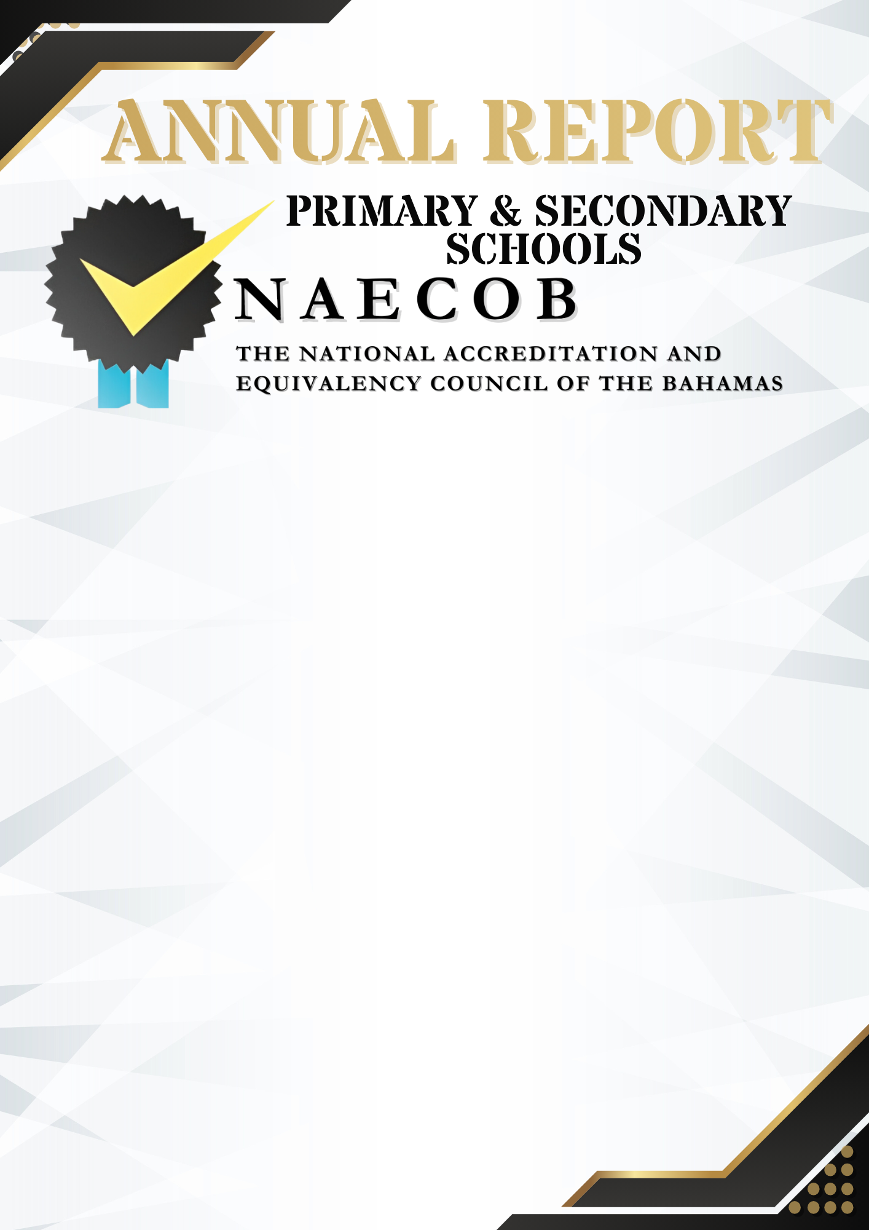

Submitted by:

Click here to enter text.

Name of Institution

Click here to enter a date.

Date of Submission

Instructions:
Institutions with more than one campus (at different locations) must submit a report for each campus.

This annual report updates the institution's status and informs NAECOB of any changes over the last operational year.
This report has seven (7) parts: General Information, Institution Details, Institutional Statistics, Institutional National Examinations, Staff and Faculty, Governance and Signature.

All faculty and staff who have obtained additional academic qualifications since the last annual report, must submit credentials/documents to NAECOB.
ANSWER ALL SECTIONS APPLICABLE TO YOUR INSTITUTION/ORGANIZATION.

Annual reports submitted after the deadline date will incur a late fee of $75.00.

PART I: GENERAL INFORMATION

ANNUAL REPORT YEAR: SEPTEMBER 2025 – JUNE 2026

NAME OF INSTITUTION: Click here to enter text.

NAME OF PROPRIETOR: Click here to enter text.

NAME OF PRINCIPAL: Click here to enter text.

PRINCIPAL’S EMAIL ADDRESS: Click here to enter text.

STREET ADDRESS: Include Building Number and Subdivision
OFFICE PHONE NUMBER: Click here to enter text.
SECONDARY PHONE NUMBER: Click here to enter text.
E-MAIL ADDRESS: Click here to enter text.
SECONDARY E-MAIL ADDRESS: Click here to enter text.
WEBSITE: Click here to enter text.

PART II: INSTITUTION DETAILS
- LEVEL OF SCHOOLING  (Please check all that apply)  ☐ Department of Education Curricula  ☐ Grade Level Assessment Test (GLAT)  ☐ Bahamas Junior Certificate (BJC)  ☐ Bahamas General Certificate of Secondary Education (BGCSE)  ☐ Other Primary/ High School Curricula  (Please specify type and duration of program/course)  Click here to enter text. | - TYPE OF INSTITUTION  (Please check all that apply)  ☐ Early Childhood  ☐ Primary School  ☐ High School  ☐ Special Needs (Please specify)  Click here to enter text.
- AFFILIATION/ACCREDITATION  Are there any new or renewal agreements?  ☐ NO ☐ YES If yes, please attach agreement.  Name of Institution: Click here to enter text.  Name of Association: Click here to enter text.  Period of Agreement: Click here to enter text. | - POLICIES  Please indicate if there are any NEW policy or changes to existing policies.  ☐ NO ☐ YES If yes, please attach new policy(s) and/or changes made.  ☐ Admissions Policy  ☐ Records Management Policy and Procedures  ☐ Instructional Staff Policy and Procedures  ☐ Student Related Policy and Procedures  ☐ Administrative & Support Staff Policy
- PHYSICAL FACILITIES  Were there any changes/adjustments to the physical facilities? (e.g, renovations, new classrooms, new buildings etc.)  ☐ NO ☐ YES  If yes, please provide details.  Click here to enter text. | - LEARNING RESOURCES  Were there any changes/additions to the learning resources?  ☐ NO ☐ YES  If yes, please provide more information.  ☐ School Management System  ☐ Electronic Library  ☐ Instructional Equipment and Supplies  ☐ Multimedia Resources  Click here to enter text.

- BUSINESS LICENSE
The institution must provide a copy of its current business license to prove its legitimacy to operate and to show good standing within the requirements and regulations of The Bahamas Business Act.

Please also provide a copy of the following, if applicable:
☐ Memorandum of Agreement
☐ Incorporation Certificate
☐ Business License
- FINANCE
The institution must provide evidence that there are sufficient funds to maintain quality educational programmes and to complete the education of all students enrolled.

- Were there any changes to the tuition fee schedule per student?

☐ NO ☐ YES If yes, please attach the tuition fee schedule.

- Were there any additional charges/sources of funding during the academic year?

☐ NO ☐ YES If yes, please provide details.

- Please attach the financial statements for the academic year in the format of a Profit and Loss Statement, Balance Sheet, and/or any other relevant financial documentation. All Grant-in-Aid recipients MUST submit an Independent Audited Report completed by an accounting firm that is a member of The Bahamas Institute of Chartered Accountants (BICA) or an independent Certified Public Accountant who is a member of BICA. Please ensure that the report has a valid signature and the BICA membership number.
- ACADEMIC YEAR (AT-A-GLANCE)
Provide an overview of the past academic year at your institution. Consider (a) highlights, (b) milestones, and (c) challenges. A FULL RESPONSE IS MANDATORY.
Click here to enter text.

PART III: INSTITUTIONAL STATISTICS
Please include the number of full-time students and the number of faculty on the date when the report is signed.

SECTION 3.I Pre-School and Primary School
SECTION 3.II Secondary School
SECTION 3.III Faculty
SECTION 3. IV Faculty and Staff Academic Qualifications Update

SECTION 3.I – PRE-SCHOOL AND PRIMARY SCHOOL
SECTION 3.II - SECONDARY SCHOOL

SECTION 3.III – FACULTY Please fill out the entire table using only numbers.
NUMBER OF FACULTY AS OF SEPTEMBER 30TH | MALE | FEMALE | FULL-TIME | PART-TIME | BAHAMIAN | NON-BAHAMIAN
NUMBER OF TEACHERS
NUMBER OF NEW TEACHERS ADDED TO STAFF THIS YEAR
NUMBER OF SUPPORT STAFF
NUMBER OF NEW SUPPORT STAFF ADDED TO THE STAFF THIS YEAR
TEACHERS WITH TEACHER’S CERTIFICATE
TEACHERS WITH A DIPLOMA OF EDUCATION

SECTION 3. IV - FACULTY AND STAFF ACADEMIC QUALIFICATIONS UPDATE
All faculty and staff who have obtained additional academic qualifications since the last annual report are to be listed below. N/A ☐

NAME | NEW QUALIFICATION | INSTITUTION & DATE AWARDED | AREA(S) OF RESPONSIBILITY
PART IV: INSTITUTIONAL NATIONAL EXAM STATISTICS

Please include grades awarded to candidates who sat the National Examinations. (PLEASE SUBMIT LAST ACADEMIC YEAR’S RESULTS.)

Section 4. A.i Primary School – Grade Level Assessment Test - GLAT (GRADE 3) N/A ☐

2025 GLAT (GRADE 3) | SUBJECT | TOTAL NUMBER OF CANDIDATES |  | A |  | B |  | C |  | D |  | E |  | F |  | G |  | U
2025 GLAT (GRADE 3) | SUBJECT | M | F | M | F | M | F | M | F | M | F | M | F | M | F | M | F | M | F
2025 GLAT (GRADE 3) | Written Comp.
2025 GLAT (GRADE 3) | Reading Comp.
2025 GLAT (GRADE 3) | Listening
2025 GLAT (GRADE 3) | Language Skills
2025 GLAT (GRADE 3) | Math Concepts
2025 GLAT (GRADE 3) | Computation
2025 GLAT (GRADE 3) | Application
2025 GLAT (GRADE 3) | TOTAL

Section 4.A.ii Primary School – Grade Level Assessment Test - GLAT (GRADE 6) N/A ☐

2025 GLAT (GRADE 6) RESULTS | SUBJECT | TOTAL NUMBER OF CANDIDATES |  | A |  | B |  | C |  | D |  | E |  | F |  | G |  | U
2025 GLAT (GRADE 6) RESULTS | SUBJECT | M | F | M | F | M | F | M | F | M | F | M | F | M | F | M | F | M | F
2025 GLAT (GRADE 6) RESULTS | Written Composition
2025 GLAT (GRADE 6) RESULTS | Reading Comprehension
2025 GLAT (GRADE 6) RESULTS | Math Concepts
2025 GLAT (GRADE 6) RESULTS | Computation
2025 GLAT (GRADE 6) RESULTS | Application
2025 GLAT (GRADE 6) RESULTS | Listening
2025 GLAT (GRADE 6) RESULTS | Science Multiple Choice
2025 GLAT (GRADE 6) RESULTS | Science Structured
2025 GLAT (GRADE 6) RESULTS | Social Studies Multiple Choice
2025 GLAT (GRADE 6) RESULTS | Social Studies Structured
2025 GLAT (GRADE 6) RESULTS | Written Composition
2025 GLAT (GRADE 6) RESULTS | TOTAL

Section 4.iii Junior High School – Bahamas Junior Certificate (BJC) N/A ☐

2025 BJC RESULTS | SUBJECT | TOTAL NUMBER OF CANDIDATES |  | A |  | B |  | C |  | D |  | E |  | F |  | G |  | U
2025 BJC RESULTS | SUBJECT | M | F | M | F | M | F | M | F | M | F | M | F | M | F | M | F | M | F
2025 BJC RESULTS | Art & Design/Craft
2025 BJC RESULTS | Spanish
2025 BJC RESULTS | English Language
2025 BJC RESULTS | English Literature
2025 BJC RESULTS | General Science
2025 BJC RESULTS | Health Science
2025 BJC RESULTS | Family & Consumer Science
2025 BJC RESULTS | Mathematics
2025 BJC RESULTS | Religious Education
2025 BJC RESULTS | Social Studies
2025 BJC RESULTS | French
2025 BJC RESULTS | Technical Drawing
2025 BJC RESULTS | TOTAL
Section 4.iv High School – Bahamas General Certificate of Secondary Education Certificate (BGCSE) N/A ☐

2025 BGCSE RESULTS TABLE 1 | SUBJECT |  | TOTAL NUMBER OF CANDIDATES |  | A |  | B |  | C |  | D |  | E |  | F |  | G |  | U
2025 BGCSE RESULTS TABLE 1 |  |  | M | F | M | F | M | F | M | F | M | F | M | F | M | F | M | F | M | F
2025 BGCSE RESULTS TABLE 1 | Keyboarding
2025 BGCSE RESULTS TABLE 1 | Bookkeeping & Accounts
2025 BGCSE RESULTS TABLE 1 | Commerce
2025 BGCSE RESULTS TABLE 1 | Economics
2025 BGCSE RESULTS TABLE 1 | Office Procedures
2025 BGCSE RESULTS TABLE 1 | Clothing Construction
2025 BGCSE RESULTS TABLE 1 | Food and Nutrition
2025 BGCSE RESULTS TABLE 1 | Language Arts
2025 BGCSE RESULTS TABLE 1 | Literature
2025 BGCSE RESULTS TABLE 1 | Spanish
2025 BGCSE RESULTS TABLE 1 | French
2025 BGCSE RESULTS TABLE 1 | Art & Design
2025 BGCSE RESULTS TABLE 1 | Art & Craft
2025 BGCSE RESULTS TABLE 1 | Music
2025 BGCSE RESULTS TABLE 1 | TOTAL
2025 BGCSE RESULTS TABLE 2 |  | SUBJECT | TOTAL NUMBER OF CANDIDATES |  | A |  | B |  | C |  | D |  | E |  | F |  | G |  | U
 |  | SUBJECT | M | F | M | F | M | F | M | F | M | F | M | F | M | F | M | F | M | F
 |  | Biology
 |  | Chemistry
 |  | Combined Science
 |  | Physics
 |  | Mathematics
 |  | History
 |  | Geography
 |  | Religious Studies
 |  | Auto Mechanics
 |  | Carpentry & Joinery
 |  | Electrical Installation
 |  | Graphical Communication
 |  | TOTAL

PART V: STAFF AND FACULTY
SECTION A: ADMINISTRATIVE AND SUPPORT STAFF
Please ATTACH copies of certificates/degrees, with the valid transcript(s) and other relevant documentation from the last Annual Report for ALL NEW HIRES. N/A ☐
Should the academic credentials and previous experience not reflect an alignment with the current or proposed position, justification for the appointment must be given.
NEW HIRES INFORMATION ONLY
NAME | NATIONALITY | QUALIFICATIONS  UNIVERSITY DEGREE/ DIPLOMA | AREA(s) OF RESPONSIBILITY | FULL-TIME OR  PART-TIME

SECTION B: FACULTY/ INSTRUCTIONAL STAFF

Please ATTACH copies of certificates/degrees, with the valid transcript(s) and other relevant documentation from the last Annual Report for ALL NEW HIRES.
Please note that a full-time administrator who teaches, is not considered full-time faculty. N/A ☐
NEW HIRES INFORMATION ONLY
NAME | MALE | FEMALE | NATIONALITY | QUALIFICATIONS |  |  | YEARS AND TYPE OF EXPERIENCE | SUBJECT(S) TAUGHT | FULL-TIME OR PART-TIME | TOTAL TEACHING LOAD IN HOURS PER WEEK
 |  |  |  | UNIVERSITY DEGREE | DIPLOMA | TEACHER’S CERTIFICATE

SECTION C: CURRENT FACULTY
Please provide the names of your school’s current faculty and staff, including the subjects they teach, or attach a separate file.
 | NAME | GRADE LEVEL/SUBJECTS TAUGHT
1
2
3
4
5
6
7
8
9
10
11
12
13
14
15

SECTION D: FACULTY & ADMINISTRATIVE STAFF NO LONGER EMPLOYED since the LAST Annual Report. N/A ☐
NAME | SEX | NATIONALITY | POSITION | YEAR(S) EMPLOYED | FULL-TIME OR PART-TIME

PART VI: GOVERNANCE
Please include the names of persons on your Board of Directors. N/A ☐
Should there be no changes to Board Members, you are required to submit one letter signed by each Board Member, verifying continued acceptance in their role on the Board should be submitted (if applicable).
BOARD OF DIRECTORS
 | NAME | OCCUPATION | TENURE
1
2
3
4
5
6
7
8

PART VII: SIGNATURE
SIGNATURE ATTESTING TO COMPLIANCE
Click here to enter text. (Name of Institution) has provided a complete and accurate disclosure of information and has attached a complete and accurate listing of all curricula offered by the institution and all substantive changes, the location of the curricula and the modes of delivery of curricula.

Signature of CEO: Date: Click here to enter a date.

Signature of Proprietor: Date: Click here to enter a date.

Signature of Principal/President/Director: Date: Click here to enter a date.

Please return completed form and supporting documents to:

The National Accreditation and Equivalency Council of The Bahamas (NAECOB)
Tonique Williams Darling Highway & Knowles Drive
P.O. Box N-3913
Nassau, N.P., The Bahamas
Telephone: 328-8872/3
Email: info@naecob.org

