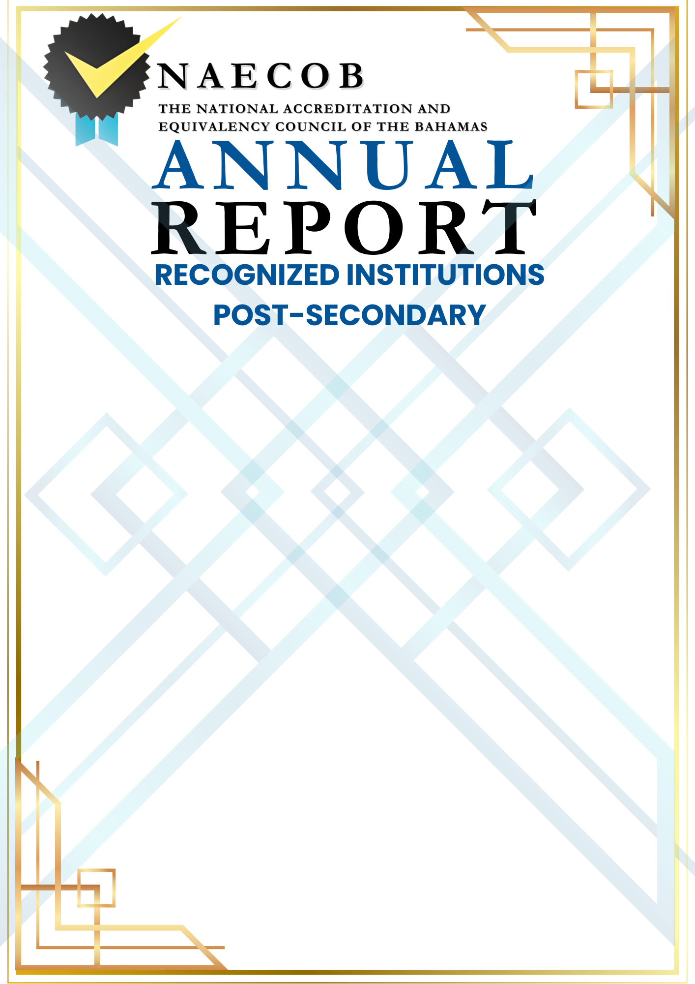

Submitted by:

Click here to enter text.
Name of Institution

Click here to enter a date.

Date of Submission

Submitted to:

National Accreditation & Equivalency Council of The Bahamas
Tonique Williams Darling Highway & Knowles Drive
P.O. Box N-3913
Nassau, N.P., The Bahamas
Email: info@naecob.org
Instructions:
This annual report updates the institution's status and informs NAECOB of any changes over the last operational year.
This report has five (5) parts: General Information, Institution Details, Institutional Statistics, Governance and Signature.

ANSWER ALL SECTIONS .

Please return the completed form to the office. An annual report submitted after the deadline date will incur a late fee of $75.00.

PART I: GENERAL INFORMATION

ANNUAL REPORT YEAR: Click or tap here to enter text.

NAME OF INSTITUTION: Click here to enter text.

TYPE OF INSTITUTION: Click here to enter text.

PROPRIETOR: Click or tap here to enter text.

CHIEF EXECUTIVE OFFICER (CEO) : Click here to enter text.

CHIEF ADMINISTRATIVE OFFICER : Click here to enter text.

CHIEF ACADEMIC OFFICER : Click here to enter text.

POSTAL ADDRESS: Click or tap here to enter text.

STREET ADDRESS: Include Building Number and Subdivision
TELEPHONE NUMBER: Click or tap here to enter text.
FAX NUMBER: Click here to enter text.
E-MAIL ADDRESS: Click here to enter text.
ALTERNATIVE E-MAIL ADDRESS: Click here to enter text.
WEBSITE: Click here to enter text.

PART II: INSTITUTION DETAILS
1. LEVEL OF PROGRAMME OFFERINGS  (Please check all that apply and for each specific type and duration)  ☐ Certificate  ☐ Diploma  ☐ Associate Degree  ☐ Bachelor’s Degree  ☐ Master’s Degree  ☐ Postgraduate work  ☐ Other Tertiary/ Post-Secondary Programmes  Click here to enter text. | 2. TYPE OF PROGRAMMES/COURSES (Please check all that apply)  ☐ Technical and Vocational  ☐ College Prep Programme  ☐ Degree-Granting Programme  ☐ General Interest/Professional Development  ☐ Other (Please specify)  Click here to enter text.
- AFFILIATION/ACCREDITATION  Are there any new or renewal agreements?  ☐ NO ☐ YES  (If yes, please attach the agreement)  Name of Institution: Click here to enter text.  Name of Association: Click here to enter text.  Period of Agreement: Click here to enter text. | - Institutional Engagement  Please indicate if there is any institutional engagement with local Bahamian bodies, universities, employers, and other stakeholders.  ☐ Local Partnerships  ☐ Career Events  ☐ Alumni Engagement  ☐ Other (Please specify)  Click here to enter text.
- SUPPORT SERVICES  Please specify the types of support services available for online Bahamian students.  ☐ Academic Advising  ☐ Technical Support  ☐ Tutoring  ☐ Other (Please specify)  Click here to enter text. | - DELIVERY FORMAT  Please provide details on how courses are delivered to students in the Bahamas.  ☐ Synchronous  ☐ Asynchronous  ☐ Hybrid  ☐ Self-paced modules  ☐ Weekly live sessions, self-paced modules

- FINANCE
The institution must have the necessary financial resources to achieve the objectives of its programmes and services.

- Were there any changes to the tuition fee schedule per student?

☐ NO ☐ YES If yes, please attach the tuition fee schedule.

- Were there any additional scholarships or grants provided to Bahamian students?

☐ NO ☐ YES If yes, please indicate the number of students being funded and total scholarship amount.
Click here to enter text.

- ACADEMIC YEAR (AT-A-GLANCE)  Elaborate on the highlights/milestones/challenges the institution would have encountered over the last year.  Click here to enter text. | - LICENCE  Please provide an updated copy of your accreditation certificate.  Click here to enter text.

PART III: INSTITUTIONAL STATISTICS

Please include the number of Bahamian full-time and part-time students, over the last operational year.

SECTION 3.I Number of Bahamian Students Enrolled at Institution

SECTION 3.II Academic Progress
SECTION 3.III Programmes Enrolled

Section 3.i– Tertiary/ Post-Secondary School
NUMBER OF BAHAMIAN STUDENTS ENROLLED
FULL TIME
AGE AS OF SEPTEMBER 30TH | UNDER 17 | 18 | 19 | 20 | 21 | 22 | 23-25 | 26-30 | 31-40 | OVER 40 | TOTAL
MALE
FEMALE
TOTAL
PART-TIME
AGE AS OF SEPTEMBER 30TH | UNDER 17 | 18 | 19 | 20 | 21 | 22 | 23-25 | 26-30 | 31-40 | OVER 40 | TOTAL
MALE
FEMALE
TOTAL

Section 3. ii: Academic Progress
The Institution should provide the academic performance of Bahamian students enrolled on the date the report is signed.
ACADEMIC PROGRESS
Metric | Value (%)
Bahamian Students Retention Rate (%)
Bahamian Students Completion Rate (%)
Total number of Bahamian student graduates over the last operational year.
Total enrollment of Bahamian students over the last operational year.

Section 3. iii: Programme Enrollment
The Institution should outline the various programmes in which Bahamian students are enrolled.
PROGRAMME ENROLLMENT
Programme Name | Level (e.g., Bachelor's, Master's) | Number of Bahamian Students Enrolled
 |  | Males | Female

PART IV: GOVERNANCE
Governance: Please include names of persons on your Board of Directors. N/A ☐
The Institution’s Governing Board must comprise a minimum of five (5) persons with specific authority over the institution and is an active policy-making body. The Board should ultimately be responsible for ensuring that financial resources are adequate to provide sound educational curricula. The CEO/President cannot be the Chair of the Board.
Should there be no changes to Board Members, you are required to submit one letter signed by each Board Member, verifying continued acceptance in their role on the Board should be submitted (if applicable).
BOARD OF DIRECTORS
 | NAME | OCCUPATION | TENURE
1
2
3
4
5
6
7
8

PART V: SIGNATURE
SIGNATURE ATTESTING TO COMPLIANCE
Click here to enter text. (Name of Institution) has provided complete and accurate disclosure of information and has attached a complete and accurate listing of all curricula offered by the institution and all substantive changes, the location of the curricula and the modes of delivery of curricula.

Signature of CEO: Date: Click here to enter a date.

Signature of Proprietor: Date: Click here to enter a date.

Signature of Principal/President/Director: Date: Click here to enter a date.

Please return completed form to:

The National Accreditation and Equivalency Council of The Bahamas (NAECOB)
Tonique Williams Darling Highway & Knowles Drive
P.O. Box N-3913
Nassau, N. P., The Bahamas
Telephone: 328-8872/3
Email: info@naecob.org

