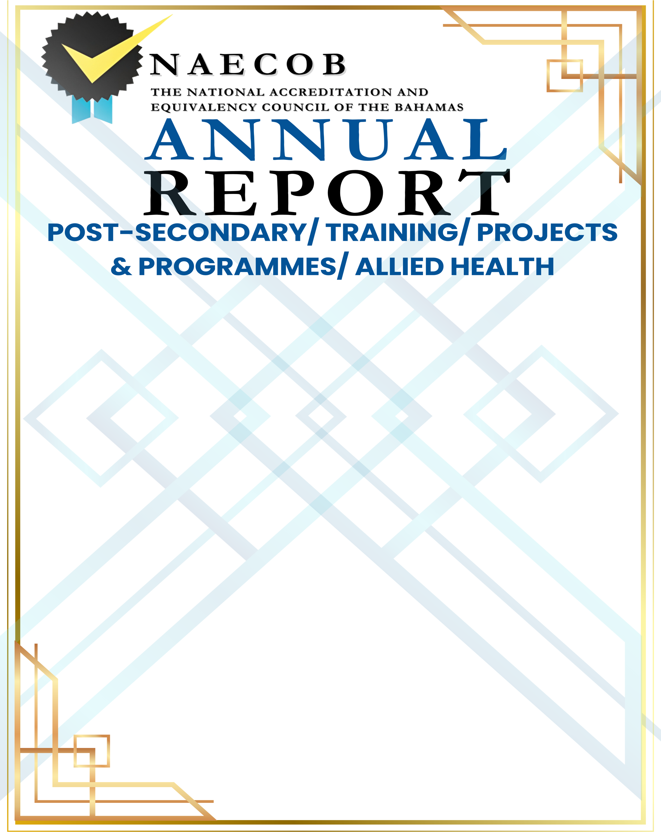

Submitted by:

Click here to enter text.
Name of Institution

Click here to enter a date.

Date of Submission

Submitted to:

National Accreditation & Equivalency Council of The Bahamas
Tonique Williams Darling Highway & Knowles Drive
P.O. Box N-3913
Nassau, N.P., The Bahamas
Email: info@naecob.org
Instructions:
Institutions with more than one campus (at different locations) must submit a report for each campus.

This annual report updates the institution's status and informs NAECOB of any changes over the last operational year.
This report has six (6) parts: General Information, Institution Details, Institutional Statistics, Staff and Faculty, Governance and Signature.

All faculty and staff who have obtained additional academic qualifications since the last annual report, must submit credentials/documents to NAECOB.
ANSWER ALL SECTIONS APPLICABLE TO YOUR INSTITUTION/ORGANIZATION.

Please return the completed form to the office. An annual report submitted after the deadline date will incur a late fee of $75.00.

PART I: GENERAL INFORMATION

ANNUAL REPORT YEAR: Click or tap here to enter text.

NAME OF INSTITUTION: Click here to enter text.

TYPE OF INSTITUTION: Click here to enter text.

PROPRIETOR: Click or tap here to enter text.

PRINCIPAL: Click here to enter text.

POSTAL ADDRESS: Click or tap here to enter text.

STREET ADDRESS: Include Building Number and Subdivision
TELEPHONE NUMBER: Click or tap here to enter text.
FAX NUMBER: Click here to enter text.
E-MAIL ADDRESS: Click here to enter text.
WEBSITE: Click here to enter text.

PART II: INSTITUTION DETAILS
1. LEVEL OF PROGRAMME OFFERINGS  (Please check all that apply and for each specific type and duration)  ☐ Certificate  ☐ Diploma  ☐ Associate Degree  ☐ Bachelor’s Degree  ☐ Master’s Degree  ☐ Postgraduate work  ☐ Other Tertiary/ Post-Secondary Programmes  Click here to enter text. | 2. TYPE OF PROGRAMMES/COURSES (Please check all that apply)  ☐ Technical and Vocational  ☐ College Prep Programme  ☐ Degree Granting Programme  ☐ General Interest/Professional Development  ☐ Other (Please specify)  Click here to enter text.
- AFFILIATION/ACCREDITATION  Are there any new or renewal agreements?  ☐ NO ☐ YES  (If yes, please attach the agreement)  Name of Institution: Click here to enter text.  Name of Association: Click here to enter text.  Period of Agreement: Click here to enter text. | - POLICIES  Please indicate if there are any NEW policies or changes to existing policies.  ☐ NO ☐ YES  (If yes, please attach new policy(s) and/or changes made.)  ☐ Admissions Policies  ☐ Records Management Policies and Procedures  ☐ Instructional Staff Policies and Procedures  ☐ Student - Related Policies and Procedures  ☐ Administrative & Support Staff Policies
- PHYSICAL FACILITIES  Were there any changes/adjustments to the physical facilities? (e.g, renovations, new classrooms, new buildings etc.)  ☐ NO ☐ YES  If yes, please provide more information.  Click here to enter text. | - LEARNING RESOURCES  Were there any changes/additions to the learning resources?  ☐ NO ☐ YES  If yes, please provide more information.  ☐ School Management System  ☐ Electronic Library  ☐ Instructional Equipment and Supplies  ☐ Multimedia Resources  Click here to enter text.

- BUSINESS LICENSE
The institution must provide a copy of its current business license, to prove its legitimacy to operate and to show good standing within the requirements and regulations of The Bahamas Business Act.

Please also provide a copy of the following if applicable:
☐ Memorandum of Agreement
☐ Incorporation Certificate
- FINANCE
The institution must have the necessary financial resources to achieve the objectives of its programmes and services. The institution must provide evidence that there are funds sufficient to maintain quality educational programmes and to complete the education of all students enrolled.

- Were there any changes to the tuition fee schedule per student?

☐ NO ☐ YES If yes, please attach the tuition fee schedule.

- Were there any additional charges/sources of funding during the academic year?

☐ NO ☐ YES If yes, please attach the tuition fee schedule.

- PLEASE ATTACH THE FINANCIAL STATEMENT AND/OR THE INDEPENDENT
AUDITOR’S REPORT FOR THE ACADEMIC YEAR. All Grant-in-Aid recipients must submit an audited report completed by an accounting firm that is a member of The Bahamas Institute of Chartered Accountants (BICA) or an independent Certified Public Accountant who is a member of BICA. Please ensure that the report has a valid signature and the BICA membership number.
- ACADEMIC YEAR (AT-A-GLANCE)  Elaborate on the highlights/milestones/challenges the institution would have encountered over the last year. A response is mandatory.  Click here to enter text. | - SUPPORTING DOCUMENTS  List any other supporting documents.  Click here to enter text.

PART III: INSTITUTIONAL STATISTICS

Please include the number of full-time and part-time students, and the number of faculty, on the date when the report is signed.

SECTION 3.I Number of Students Enrolled at Institution
SECTION 3.II Number of Faculty
SECTION 3.III Faculty and Staff Academic Qualifications Update

Section 3.i– Tertiary/ Post-Secondary School/Projects & Programmes
NUMBER OF STUDENTS ENROLLED
FULL TIME
AGE AS OF SEPTEMBER 30TH | UNDER 17 | 18 | 19 | 20 | 21 | 22 | 23-25 | 26-30 | 31-40 | OVER 40 | TOTAL
MALE
FEMALE
TOTAL
PART-TIME
AGE AS OF SEPTEMBER 30TH | UNDER 17 | 18 | 19 | 20 | 21 | 22 | 23-25 | 26-30 | 31-40 | OVER 40 | TOTAL
MALE
FEMALE
TOTAL

NUMBER OF FACULTY AS OF SEPTEMBER 30TH | MALE | FEMALE | FULL-TIME | PART-TIME | BAHAMIAN | NON-BAHAMIAN
NUMBER OF TEACHERS
TEACHERS ADDED TO STAFF THIS YEAR
SUPPORT STAFF ADDED TO STAFF THIS YEAR
TEACHERS WITH TEACHER’S CERTIFICATE
TEACHERS WITH DIPLOMA OF EDUCATION
Section 3.ii – Faculty Numbers
Please complete the table in its entirety.

Section 3. iii: Faculty and Staff Academic Qualifications Update
All faculty and staff who have obtained additional academic qualifications since the last annual report. N/A ☐

FACULTY AND STAFF ACADEMIC QUALIFICATIONS UPDATE
NAME | NEW QUALIFICATION | INSTITUTION & DATE AWARDED | AREA(S) OF RESPONSIBILITY

PART IV: STAFF AND FACULTY
Section A: Administrative and Support Staff
The Institution has qualified administrative officers with the experience and competence to lead the institution. Should academic credentials and previous experience not reflect an alignment with the current or proposed position, justification for the appointment must be given.
- Update table to include information for NEW HIRES ONLY since the last annual report submission. N/A ☐
ADMINISTRATIVE AND SUPPORT STAFF
New Hires Only
NAME | NATIONALITY | QUALIFICATIONS  UNIVERSITY DEGREE/ DIPLOMA | AREA OF RESPONSIBILITY | FULL-TIME OR  PART-TIME

Section B: Faculty
Please include copies of certificates/degrees with valid transcript(s) and other relevant documentation from the last Annual Report for ALL NEW HIRES.
Please note that a full-time administrator who teaches, is not considered full-time faculty. N/A ☐
FACULTY/ INSTRUCTIONAL STAFF
New Hires Only
NAME | MALE | FEMALE | NATIONALITY | QUALIFICATIONS |  |  | YEARS AND TYPE OF EXPERIENCE | SUBJECT(S) TAUGHT | FULL-TIME OR PART-TIME | TOTAL TEACHING LOAD IN HOURS PER WEEK
 |  |  |  | UNIVERSITY DEGREE | DIPLOMA | TEACHER’S CERTIFICATE

Section C: Current Faculty
Please attach a copy of your current staff list, including the subjects being taught. Ensure that it includes supply teachers, itinerant teachers, and teacher’s aides. (where applicable).
 | NAME | SUBJECTS TAUGHT
1
2
3
4
5
6
7
8
9
10

Section D: Faculty & Administrative Staff No Longer Employed since the LAST Annual Report. N/A ☐
TEACHERS AND ADMINISTRATIVE/SUPPORT STAFF NO LONGER EMPLOYED
NAME | SEX | NATIONALITY | POSITION | YEAR(S) EMPLOYED | FULL-TIME OR PART-TIME

PART V: GOVERNANCE
Governance: Please include names of persons on your Board of Directors. N/A ☐
The Institution’s Governing Board must comprise a minimum of five (5) persons with specific authority over the institution and is an active policy-making body. The Board should ultimately be responsible for ensuring that financial resources are adequate to provide sound educational curricula. The CEO/President cannot be the Chair of the Board.
Should there be no changes to Board Members, you are required to submit one letter signed by each Board Member, verifying continued acceptance in their role on the Board should be submitted (if applicable).
BOARD OF DIRECTORS
 | NAME | OCCUPATION | TENURE
1
2
3
4
5
6
7
8

PART VI: SIGNATURE
SIGNATURE ATTESTING TO COMPLIANCE
Click here to enter text. (Name of Institution) has provided complete and accurate disclosure of information and has attached a complete and accurate listing of all curricula offered by the institution and all substantive changes, the location of the curricula and the modes of delivery of curricula.

Signature of CEO: Date: Click here to enter a date.

Signature of Proprietor: Date: Click here to enter a date.

Signature of Principal/President/Director: Date: Click here to enter a date.

Please return completed form to:

The National Accreditation and Equivalency Council of The Bahamas (NAECOB)
Tonique Williams Darling Highway & Knowles Drive
P.O. Box N-3913
Nassau, N. P., The Bahamas
Telephone: 328-8872/3
Email: info@naecob.org

