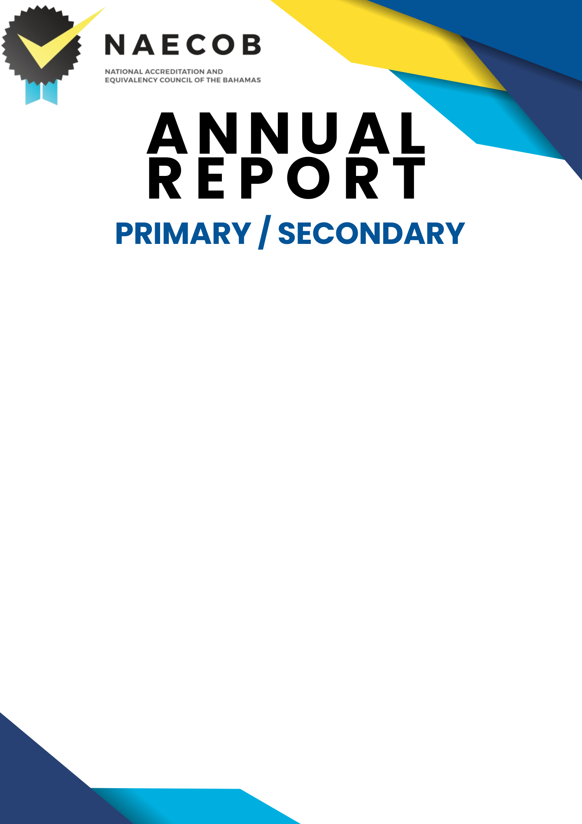

Submitted by:

Click here to enter text.

Name of Institution

Click here to enter a date.

Date of Submission

Submitted to:

National Accreditation & Equivalency Council of The Bahamas
Tonique Williams Darling Highway & Knowles Drive
P.O. Box N-3913
Nassau, N.P., The Bahamas
Email: info@naecob.org

Instructions:
Institutions with more than one campus must submit a report for each campus. This does not apply to comprehensive schools (Pre-Kindergarten to Grade 12) at one location.

This annual report is to update the institution's status over the last operational year and make NAECOB aware of any changes. Please return the completed form to the office.

Only new information should be provided (since the submission of the last Annual Report).
This report has seven (7) parts: General Information, Institution Details, Institutional Statistics, Institutional National Examinations, Staff and Faculty, Governance and Signature.

All new faculty who would have obtained additional academic qualifications since the last annual report, must submit credentials/ documents to NAECOB.
ANSWER ALL SECTIONS APPLICABLE TO YOUR INSTITUTION/ORGANIZATION.

PART I: GENERAL INFORMATION

ANNUAL REPORT YEAR: Click here to enter text.

NAME OF INSTITUTION: Click here to enter text.

TYPE OF INSTITUTION: Click here to enter text.

PROPRIETOR: Click here to enter text.

PRINCIPAL: Click here to enter text.

POSTAL ADDRESS: Click here to enter text.

STREET ADDRESS: Include Building Number and Subdivision
TELEPHONE NUMBER: Click here to enter text.
FAX NUMBER: Click here to enter text.
E-MAIL ADDRESS: Click here to enter text.
WEBSITE: Click here to enter text.

PART II: INSTITUTION DETAILS
- LEVEL OF CURRICULA  (Please check all that apply)  ☐ Department of Education Curricula  ☐ Grade Level Assessment Test (GLAT)  ☐ Bahamas Junior Certificate (BJC)  ☐ Bahamas General Certificate of Secondary Education (BGCSE)  ☐ Other Primary/ High School Curricula  (Please specify type and duration of program/course)  Click here to enter text. | - TYPE OF INSTITUTION  (Please check all that apply)  ☐ Early Childhood  ☐ Primary School  ☐ High School  ☐ Special Needs (Please specify  Click here to enter text.)
- AFFILIATION/ACCREDITATION  Are there any new agreements or renewal agreements?  ☐ NO ☐ YES If yes, please attach agreement.  Name of Institution: Click here to enter text.  Name of Association: Click here to enter text.  Period of Agreement: Click here to enter text. | - POLICIES  Please indicate if there are any NEW polices or if changes were made to existing policies.  ☐ NO ☐ YES If yes, please attach new policy(s) and/or changes made.  ☐ Admissions Policies  ☐ Records Management Policies and Procedures  ☐ Instructional Staff Policies and Procedures  ☐ Student- Related Policies and Procedures  ☐ Administrative & Support Staff Policies
- PHYSICAL FACILITIES  Were there any changes/adjustments to the physical facilities of your institution? (e.g, renovations, new classrooms, new buildings etc.)  ☐ NO ☐ YES  If yes, please provide more information.  Click here to enter text. | - LEARNING RESOURCES  Were there any changes/additions to the learning resources at the institution?  ☐ NO ☐ YES  If yes, please provide more information.  ☐ School Management System  ☐ Electronic Library  ☐ Instructional Equipment and Supplies  ☐ Multimedia Resources  Click here to enter text.

- BUSINESS LICENSE
The institution must provide a copy of a current business license to prove its legitimacy to operate and to show good standing within the requirements and regulations of The Bahamas Business Act.

Please also provide a copy of the following, where applicable:
☐ Business license
☐ Memorandum of agreement
☐ Incorporation certificate
- FINANCE
The institution must have the necessary financial resources, to achieve the objectives of its programmes and services, and must provide evidence that there are funds sufficient to maintain quality educational programmes and to complete the education of all students enrolled. Financial Statements and an independent auditor’s report(s) should be provided, of the total operation of the institution (as soon as possible).

- Were there any changes to the tuition fee schedule per student?

☐ NO ☐ YES If yes, please attach the tuition fee schedule.

- Were there any additional charges/sources of funding during the academic year?

☐ NO ☐ YES If yes, please attach the tuition fee schedule.

c. PLEASE ATTACH THE INDEPENDENT AUDITOR’S REPORT FOR THE ACADEMIC YEAR.
- ACADEMIC YEAR (AT-A-GLANCE)  Elaborate on the highlights/milestones/challenges the institution would have encountered over the last year.  Click here to enter text. | - SUPPORTING DOCUMENTS  List any other supporting documents.  Click here to enter text.

PART III: INSTITUTIONAL STATISTICS
Please include number of full time students at the date when the report is signed.

SECTION 3.I Pre-School and Primary School
SECTION 3.II High School
SECTION 3.III Faculty

Section 3.i– Pre-School and Primary School
NUMBER OF PRE-SCHOOL and PRIMARY STUDENTS
AGE AS OF SEPTEMBER 30TH | 2 YEARS AND UNDER | 3 | 4 | 5 | 6 | 7 | 8 | 9 | 10 | OVER 11 | TOTAL
MALE
FEMALE
TOTAL

NUMBER OF STUDENTS AS OF SEPTEMBER 30TH | _{PRE-SCHOOL} | _{KINDER-GARTEN} | _{GRADE}  ₁ | _{GRADE}  ₂ | _{GRADE}  ₃ | _{GRADE 4} | _{GRADE}  ₅ | _{GRADE}  ₆ | _{TOTAL}
MALE
FEMALE
TOTAL

Section 3.ii - High School
NUMBER OF HIGH SCHOOL STUDENTS
FULL TIME
AGE AS OF SEPTEMBER 30TH | 11 | 12 | 13 | 14 | 15 | 16 | 17 | 18 | 19 | OVER 19 | TOTAL
MALE
FEMALE
TOTAL

NUMBER OF STUDENTS AS OF SEPTEMBER 30TH | GRADE  7 | GRADE  8 | GRADE  9 | GRADE  10 | GRADE  11 | GRADE  12 | TOTAL
MALE
FEMALE
TOTAL

Section 3.iii- Faculty

NUMBER OF FACULTY AS OF SEPTEMBER 30TH | MALE | FEMALE | FULL-TIME | PART-TIME | BAHAMIAN | NON-BAHAMIAN
TOTAL NUMBER OF TEACHERS
TEACHERS ADDED TO STAFF THIS YEAR
SUPPORT STAFF ADDED TO STAFF THIS YEAR
TEACHERS WITH TEACHER’S CERTIFICATE/ DIPLOMA OF EDUCATION

PART IV: INSTITUTIONAL NATIONAL EXAM STATISTICS

Please include grades awarded of candidates who sat the National Exams. Please submit last academic year’s results.

Section 4.i Primary School – Grade Level Assessment Test- GLAT (GRADE 3)
Section 4.ii Primary School – Grade Level Assessment Test- GLAT (GRADE 6)
Section 4.iii Junior High School – Bahamas Junior Certificate (BJC)
Section 4. iv High School – Bahamas General Certificate of Secondary Certificate (BGCSE)

Section 4.A.i Primary School – Grade Level Assessment Test- GLAT (GRADE 3) N/A ☐

YEAR | GRADES | TOTAL NUMBER OF CANDIDATES | A | B | C | D | E | F | G | U
20XX | FEMALES
 | MALES
 | TOTAL

Section 4.A.ii Primary School – Grade Level Assessment Test- GLAT (GRADE 6) N/A ☐

YEAR | GRADES | TOTAL NUMBER OF CANDIDATES | A | B | C | D | E | F | G | U
20XX | FEMALES
 | MALES
 | TOTAL

Section 4.iii Junior High School – Bahamas Junior Certificate (BJC) N/A ☐

YEAR | GRADES | TOTAL NUMBER OF CANDIDATES | A | B | C | D | E | F | G | U
20XX | FEMALES
 | MALES
 | TOTAL

Section 4.iv High School – Bahamas General Certificate of Secondary Certificate (BGCSE) N/A ☐

YEAR | GRADES | TOTAL NUMBER OF CANDIDATES | A | B | C | D | E | F | G | U
20XX | FEMALES
 | MALES
 | TOTAL

PART V: STAFF AND FACULTY
Section A: Administrative and Support Staff
The Institution has qualified administrative officers with the experience and competence to lead the institution. Should academic credentials and previous experience not reflect an alignment with the current or proposed position, justification for the appointment must be given.
- Update table to include information for NEW HIRES ONLY since last annual report submission.

ADMINISTRATIVE AND SUPPORT STAFF
New Hires Only
NAME | NATIONALITY | QUALIFICATIONS  UNIVERSITY DEGREE/ DIPLOMA | AREA OF RESPONSIBILITY | FULL-TIME OR  PART-TIME

Section B: Faculty
Please include copies of certificates/degrees and other relevant documentation from the last Annual Report for ALL NEW HIRES.
Please note that a full-time administrator who teaches, is not considered full-time faculty.

FACULTY/ INSTRUCTIONAL STAFF
New Hires Only
NAME | MALE | FEMALE | NATIONALITY | QUALIFICATIONS |  |  | YEARS AND TYPE OF EXPERIENCE | SUBJECT(S) TAUGHT | FULL-TIME OR PART-TIME | TOTAL TEACHING LOAD IN HOURS PER WEEK
 |  |  |  | UNIVERSITY DEGREE | DIPLOMA | TEACHER’S CERTIFICATE

Section C: Current Faculty
Please attach a copy of your current staff list and ensure that it includes supply teachers, itinerant teachers and teacher’s aides.

Section D: Faculty & Administrative Staff No Longer Employed
Please include the information for all faculty and administrative staff who have not returned since the LAST Annual Report.
TEACHERS AND ADMINISTRATIVE/SUPPORT STAFF NO LONGER EMPLOYED
NAME | SEX | NATIONALITY | POSITION | YEAR(S) EMPLOYED | FULL-TIME OR PART-TIME | REASON FOR LEAVE

PART VI: GOVERNANCE
Governance: Please include names of persons on your Board of Directors.
The Institution’s Governing Board must comprise a minimum of five (5) persons with specific authority over the institution and is an active policy-making body. The Board should ultimately be responsible for ensuring that financial resources are adequate to provide sound educational curricula. The CEO/President cannot be the Chair of the Board.
Should there be no changes to Board Members, one letter signed by each Board Member verifying continued acceptance in their role on the Board should be submitted. (If applicable)
BOARD OF DIRECTORS
 | NAME | OCCUPATION | TENURE
1
2
3
4
5
6
7
8

PART VII: SIGNATURE
SIGNATURE ATTESTING TO COMPLIANCE
Click here to enter text. (Name of Institution) has provided complete and accurate disclosure of information and has attached a complete and accurate listing of all curricula offered by the institution and all substantive changes, the location of the curricula and the modes of delivery of curricula.

Signature of CEO: Date: Click here to enter a date.

Signature of Proprietor: Date: Click here to enter a date.

Signature of Principal/President/Director: Date: Click here to enter a date.

Please return completed form to:

The National Accreditation and Equivalency Council of The Bahamas (NAECOB)
Tonique Williams Darling Highway & Knowles Drive
P.O. Box N-3913
Nassau, N.P., The Bahamas
Telephone: 328-8872/3
Email: info@naecob.org

